INTERNATIONAL RESEARCH JOURNAL OF PHARMACY ISSN 2230 – 8407
Available online http://www.irjponline.com

Review Article
IN VITRO FERTILIZATION

Hadawale N. M¹*, Thorat R. M.¹, Gaikwad D. D.², Jadhav S. L.²
¹Vishal Junnar Seva Mandal Institute of Pharmacy, A/P Ale, Tal-Junnar, Pune, M.H., India
² Vishal Institute of Pharmaceutical Education And Research, A/P Ale, Tal-Junnar, Pune, M.H., India Article Received on: 12/05/11 Revised on: 23/06/11 Approved for publication: 14/07/11
*Miss. Nilam M. Hadawale, Vishal Junnar Seva Mandal Institute of Pharmacy, A/P Ale, Tal-Junnar, Dist-Pune- 412411, M.H., India, E-mail: nil_had@rediffmail.com, rupali.78@rediffmail.com

ABSTRACT
First written document dealing with infertility may be found in the Kahoun papyrus (oldest Egyptian medical text), dated to 2200-1950 BC. The early attribution of infertility to women persisted for centuries and was often considered divine punishment.
Infertility means 1 year of well-timed, unprotected intercourse without a pregnancy. The study shows about 10-15% of population is infertile. And 15-20% of couple have unexplained infertility (work-up is negative). Normally women are born with their lifetime egg supply, the Fertility initially declines at age 27.Significant decline at age 37-38. The chances of pregnancies are rare after age 44 besides this defect in female ovary, fallopian tube, uterus, and fibroid tumour causes infertility in female.
Abnormality in sperm production and abnormality in sperm function causes infertility in male.
To overcome the infertility egg are harvested from womens ovary and fertilized in laboratory with the sperm the embryos are then transfer into uterus known as In Vitro Fertilization.
KEYWORDS: Infertility, IVF, Assisted hatching, Surrogacy.

INTRODUCTION
The infertility is one year well timed unprotected, intercourse without a pregnancy. The factors which cause infertility are; Female infertility the inability to conceive, occur in about 10%of all women of reproductive age .It may be caused by ovarian disease obstruction of uterian tube. Male infertility (sterility) is an inability to fertilize a secondary oocytes; it does not imply erectile dysfunction. Male fertility require production of adequate quantity of viable , normal sperm by testis unobstructed transport of sperm through the duct the satisfactory deposition in vagina The seminiferous tubules are sensitive to many factor x-ray, infection, malnutrition, higher than scrotal temperature^{1,3}.
Many fertility expanding techniques now exist for assisting infertile to couples to have a baby the birth of Louise Joy Brown on July 12,1978.near Manchester
,England was first recorded case of in vitro fertilization (IVF) .it is a fertilization in a laboratory dish .in IVF a mother –to-be is given follicle-stimulating hormones (FSH)soon after menstruation so that several secondary oocytes will be produced when several secondary oocytes rather than single will be produced called super ovulation .when several follicles have reaches appropriate size ,a small incision is made near the umbilicus and the secondary oocytes are aspirated from the stimulated follicles and transferred to a solution
containing sperm where the oocytes undergoes fertilization⁴.
According to the American Society for Reproductive Medicine (ASRM), Age, Smoking, Sexually Transmitted Infections, and Being Overweight or Underweight can all affect fertility.

Smoking
Smoking is harmful to the ovaries, and the degree of damage is dependent upon the amount and length of time a woman smokes. Nicotine and other harmful chemicals in cigarettes interfere with the body’s ability to create estrogen, a hormone that regulates folliculogenesis and ovulation. Also, cigarette smoking interferes with folliculogenesis.

Sexually transmitted infection
Sexually transmitted infections are a leading cause of infertility like Fallopian Tubes Infection (Chlamydia).Infection Caused by both bacteria and viruses and usually transmitted sexually, these infections commonly cause inflammation resulting in scarring and damage. A specific example is Hydrosalpnix, a condition in which the fallopian tube is occluded at both ends and fluid collects in the tube.

Body weight and eating disorders
Twelve percent of all infertility cases are a result of a woman either being underweight or overweight. Fat cells produce estrogen, in addition to the primary sex organs. Too much body fat causes production of too much

estrogen and the body begins to react as if it is on birth control, limiting the odds of getting pregnant. Too little body fat causes insufficient production of estrogen and disruption of the menstrual cycle. Both under and overweight women have irregular cycles in which ovulation does not occur or is inadequate.

Other factors
- Ovarian factors
  - Polycystic ovary syndrome
  - Anovulation
  - Diminished ovarian reserve, also see Poor Ovarian Reserve
  - Premature menopause
  - Menopause
  - Luteal dysfunction
  - Gonadal dysgenesis ( Turner syndrome )
  - Ovarian cancer

Vaginal factors
  - Vaginismus
  - Vaginal obstruction

Genetic factors
Various intersexed conditions, such as androgen insensitivity syndrome MRKH, or Mayer-Rokitansky – Küster - Hauser Syndrome, is a condition involving primary amenorrhea and an underdeveloped uterus. Women with MRKH are biologically female and are believed to occur in 1 in every 5,000 females.

Hormonal Problems
These are the most common causes of anovulation. The process of ovulation depends upon a complex balance of hormones and their interactions to be successful, and any disruption in this process can hinder ovulation. There are three main sources causing this problem⁵⁻⁷
IN VITRO FERTILIZATION
Egg cells are fertilized outside the woman’s body. The process involves hormonally controlling the ovulatory process, removing ova (eggs) from the woman's ovaries and letting sperm fertilise them in a fluid medium. The fertilised egg (zygote) is then transferred to the patient's uterus with the intent to establish a successful pregnancy¹.

Expansions of IVF
The following are techniques involved in, or requiring, in vitro fertilization. In vitro fertilization does not necessarily involve each technique.

Transvaginal ovum retrieval (OCR)
It is the process whereby a small needle is inserted through the back of the vagina and guided via ultrasound into the ovarian follicles to collect the fluid that contains the eggs.

Assisted zona hatching (AZH)
It is performed shortly before the embryo is transferred to the uterus. A small opening is made in the outer layer surrounding the egg in order to help the embryo hatch out and aid in the implantation process of the growing embryo.

Intracytoplasmic sperm injection (ICSI)
ICSI is beneficial in the case of male factor infertility where sperm counts are very low or failed fertilization occurred with previous IVF attempt(s). The ICSI procedure involves a single sperm carefully injected into the center of an egg using a microneedle. This method is also sometimes employed when donor sperm is used.
Autologous endometrial coculture is a possible treatment for patients who have failed previous IVF attempts or who have poor embryo quality. The patient's fertilized eggs are placed on top of a layer of cells from the patient's own uterine lining, creating a more natural environment for embryo development.

Zygote intrafallopian transfer (ZIFT)
In Zygote intrafallopian transfer, egg cells are removed from the woman's ovaries and fertilized in the laboratory; the resulting zygote is then placed into the fallopian tube. Cytoplasmic transfer is the technique in which the contents of a fertile egg from a donor are injected into the infertile egg of the patient along with the sperm.
Egg donors are resources for women with no eggs due to surgery, chemotherapy, or genetic causes; or with poor egg quality, previously unsuccessful IVF cycles or advanced maternal age. In the egg donor process, eggs are retrieved from a donor's ovaries, fertilized in the laboratory with the sperm from the recipient's partner, and the resulting healthy embryos are returned to the recipient's uterus.
A gestational carrier is an option when a patient's medical condition prevents a safe pregnancy, when a patient has ovaries but no uterus due to congenital absence or previous surgical removal, and where a patient has no ovaries and is also unable to carry a pregnancy to full term.
- Preimplantation genetic diagnosis (PGD) Preimplantation genetic diagnosis involves the use of genetic screening mechanisms such as Fluorescent In Situ Hybridization (FISH) or Comparative Genomic Hybridization (CGH) to help identify genetically abnormal embryos and improve healthy outcomes. Embryo splitting can be used for twinning to increase the number of available embryos.⁸

Assisted Hatching
These technologies help provide infertile couples with tools to bypass the normal mechanisms of gamete transportation. Probability of pregnancy in healthy

couples is 30-40% per cycle by assisted hatching technique, live birth rate 25%.but the rate is depend on varies.

Embryo transfer
Embryos are graded by number of cells, evenness of growth degree of fragmentation.
The age of the woman other health and diagnostic factors. A maximum of two embryos are transferred except in unusual circumstances. The embryos judged to be the "best" are transferred to the patient's uterus through a thin, plastic catheter, which goes through her vagina and cervix. Several embryos may be passed into the uterus to improve chances of implantation and pregnancy. Embryos are graded by the embryologist based on the number of cells, evenness of growth and degree of fragmentation. The number to be transferred depends on the number available, the age of the woman and other health and diagnostic factors. In countries such as Canada, the UK, Australia and New Zealand, a maximum of two embryos are transferred except in unusual circumstances. In the UK and according to HFEA regulations, a woman over 40 may have up to three embryos transferred, whereas in the USA, younger women may have many embryos transferred based on individual fertility diagnosis. Most clinics and country regulatory bodies seek to minimize the risk of pregnancies carrying multiples. As it is not uncommon for more implantations to take than desired, the next step faced by the expectant mother is that of selective abortion. The embryos judged to be the "best" are transferred to the patient's uterus through a thin, plastic catheter, which goes through her vagina and cervix. Several embryos may be passed into the uterus to improve chances of implantation and pregnancy⁹.

Egg donation
IVF process is available for both know or anonymous. Donor should have age above 35 years; donor should have standard controlled overian stimulation. and Egg retrieval. and recipient embryo transfer²

Who are candidates to be an egg donor?
  - 21-35 years old (older if a friend or relative)
  - FSH level should not exceed above 10
  - Good health and genetic history
  - Preferably prior egg donation experience

Who are candidates for egg donation ?
  - Premature ovarian failure
  - Ovarian insufficiency (e.g. FSH>15 )
  - Physiologic menopause
  - Maternal age over 43
  - History of poor egg/embryo quality or multiple IVF failures²

Surrogate motherhood
In the United States, the issue of surrogacy was widely publicized in the case of Baby M, in which the surrogate and biological mother of Melissa Stern ("Baby M"), born in 1986, refused to cede custody of Melissa to the couple with whom she had made the surrogacy agreement. The courts of New Jersey found that Mary Beth Whitehead was the child's legal mother and declared contracts for surrogate motherhood illegal and invalid. However, the court found it in the best interests of the infant to award custody of Melissa to her biological father William Stern and his wife Elizabeth Stern, rather than to the surrogate mother Mary Beth Whitehead. There have been cases of clashes between surrogate mothers and the genetic parents when unexpected complications with the fetus makes the genetic parents ask for an abortion even though the surrogate mother is opposed. Commercial surrogacy is legal in India, as recognized by the Supreme Court of India in 2002.¹¹ India is emerging as a leader in international surrogacy and a destination in surrogacy- related fertility tourism. Indian surrogates have been increasingly popular with fertile couples in industrialized nations because of the relatively low cost. Indian clinics are at the same time becoming more competitive, not just in the pricing, but in the hiring and retention of Indian females as surrogates. Clinics charge patients between
$10,000 and $28,000 for the complete package, including fertilization, the surrogate's fee, and delivery of the baby at a hospital. Including the costs of flight tickets, medical procedures and hotels, it comes to roughly a third of the price compared with going through the procedure in the UK. The Hon'bl Supreme Court of india has given the verdict that the citizenship of the child born through this process will have citizenship of its surrogate mother¹².
Surrogacy is a third party reproduction arrangement whereby a woman agrees to become pregnant for the purpose of gestating and giving birth to a child for others to raise. She may be the child's genetic mother or not, depending on the type of arrangement agreed to.
A surrogate mother is a woman who carries a child for a couple or single person with the intention of giving that child to that person / people once the being is born (also called surrogate pregnancy). The surrogate mother may be the baby's biological mother (traditional surrogacy) or she may be implanted with someone else's fertilized egg (gestational surrogacy) ^{3,} ^{10.}

REFERENCES |  |  |  |  | 8. | Illmensee K, Levanduski M, Vidali A, Husami N, Goudas VT,
1. Satyanarayan | U, | Assisted | Reproductive | Technology, |  | Human embryo twinning with applications in reproductive

Biotechnology, Uppala author publisher, 2005, pp.230.
- Mishra RK, Antifertility effect, Indian Journal of Experimental Biology, 2009, 47:0019-5189, 706.
- Center for disease control & preventions, Division of Reproductive Health, Assisted Reproductive Success Rate’2001.
- Tortora & Grabowski, Principles of Anatomy & Physiology,10th edition, John Wiley & Sons Inc, Tenth edition, pp.1099-1100.
- Rowe PJ, Comhaire FH, Hargreave TB, Mahmoud MA, WHO Manual for the Standardized Investigation, Diagnosis and Management of the Infertile female. Cambridge University Press, 2000. ISBN 0-521-77474-8.
- http://www.about health.com/2008/2009/female infertility result and test.
- http://www.emedicine .com/med/topic1167.htm
medicine, Fertil. Steril., February 2009 93 (2): 423–7.
- Rochebrochard E, Quelen C, Peikrishvili R, Guibert J, Bouyer J "Long-term outcome of parenthood project during in vitro fertilization and after discontinuation of unsuccessful in vitro fertilization". Fertil. Steril. August 2008, 92 (1): 149–56.
- Cooper TG, Noonan E, Eckardstein S, et al. “World Health Organization reference values for human semen characteristics". Hum. Reprod. Update 2010, 16 (3): 231–45.
- http://www.nydailynews.com/news/us_world/2007/12/30/2007- 12-30_indias_surrogate_mother_business_raises_- 2.html?page=0.
- Kannan S, India Business Report, BBC World. Retrieved on 23 Mar, 2009.

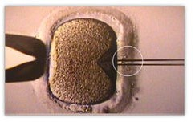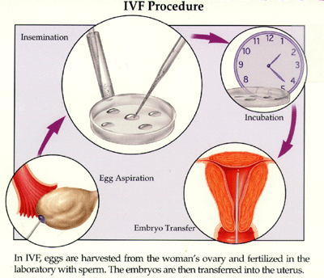

Fig 1. Assisted zona hatching Fig.No.2: IVF Procedure
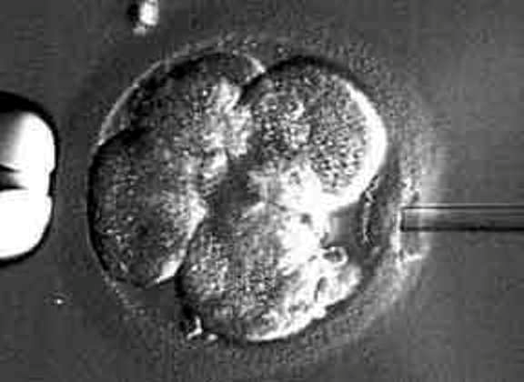

Fig. No. 3: Intracytoplasmic Sperm Injection
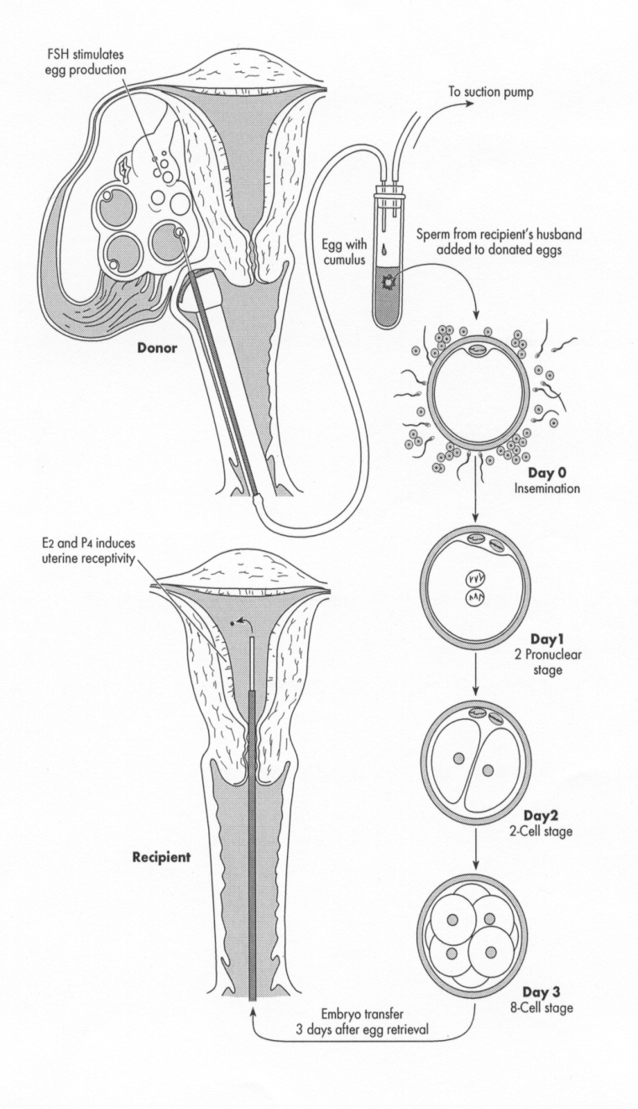
Fig.No.4: Egg donation

